* Duplicate an object [Shift + D]
* Mesh Select Mode [ctr + Tab]
* Move cursor back to the origin [shift + C]
* Different perspective in one [ctr + alt + Q]
* Property panel [n]
* Bevel (Fase) [ctr + B]
* Rotate around the object [MMB] -> Middle Mouse Button
* Move the Viewport [Shift + MMB]
* Zoom in and out [ctr + MMB] or Mouse wheel
* Minimize or show Toolbar [T]
* Inset Faces [I]
* Separate selected geometry [P]
* Select next active face [Shift + Ctr + Numpad +]

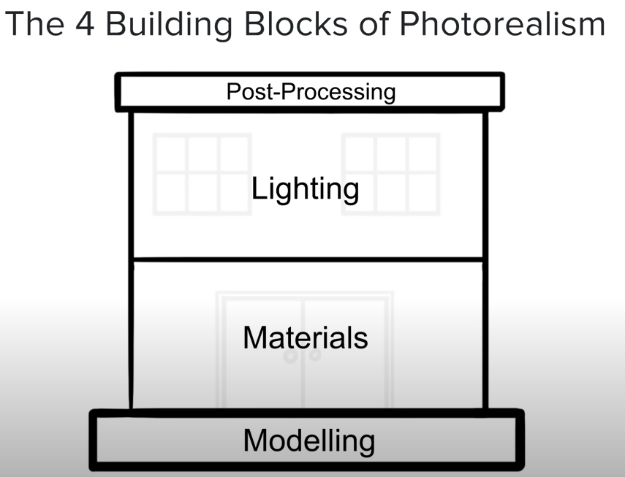

Photorealistic **modelling** is…

Matching the proportions and form of the real world object.

**Tip #1:** Keep it in Real World Scale

**Tip #2:** Never a sharp edge!

**Tip #3:** Use Reference! (Nothing beats the real thing)

**Tip #4:** Know your anatomy

Photorealistic **materials** are…

When the shading and textures matches real world materials.

**Tip #1:** Use Physically Accurate Shaders

**Tip #2:** Use PBR Maps

**Tip #3:** Use surface imperfection

Photorealistic **lighting** is…

Light that matches the color, direction and intensity seen in real life.

**Tip #1:** Use real-world light direction

**Tip #2:** Use the correct color

**Tip #3:** Don’t forget reflections! (Use HDRs if possible)

Photorealistic **post-processing** is… (camera)

Recreating imperfections from real life cameras.

Five Main imperfections:

1. Light Glare
2. Motion Blur
3. Depth of Field
4. Chromatic Aberration
5. Barrel Distortion

**18 Ways to Speed Up Blender Cycles Rendering**

1. **Reduce Light Bounces**

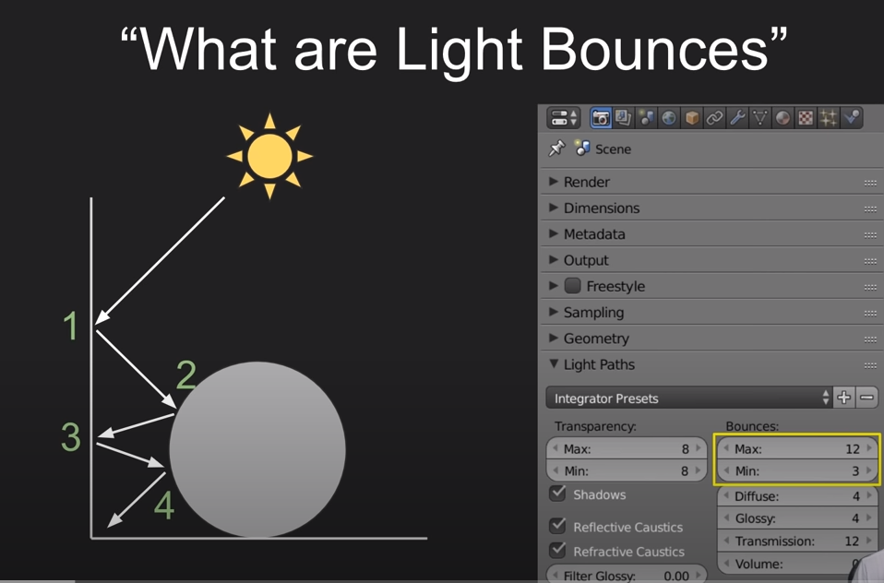

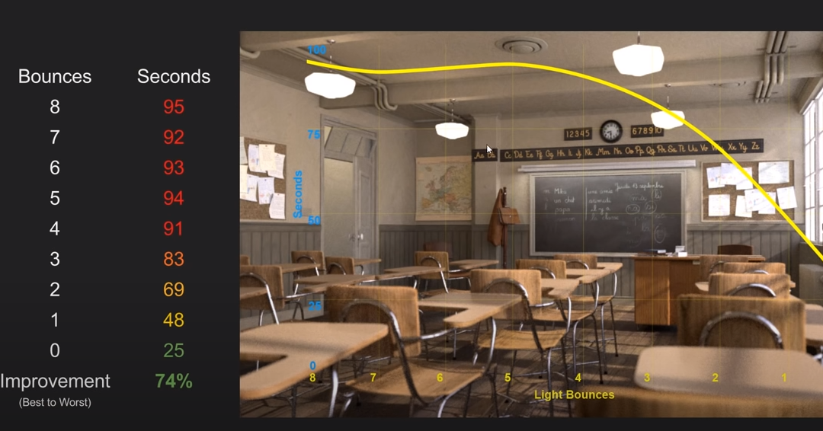

1. **Use Portals**

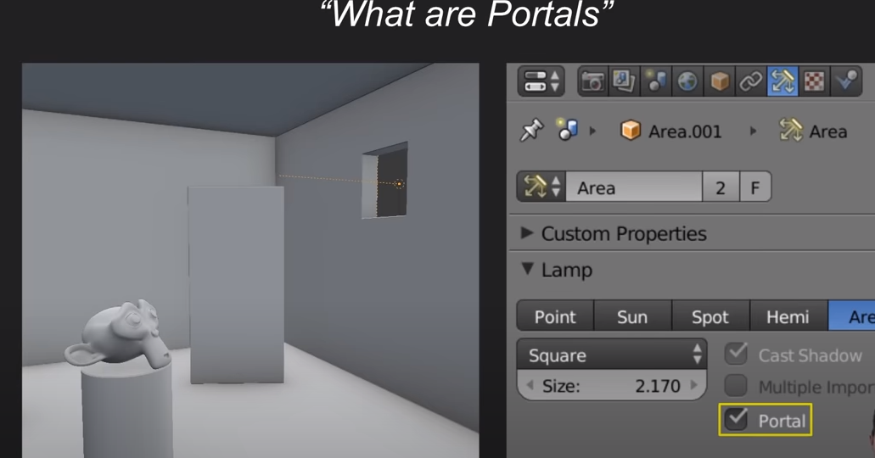

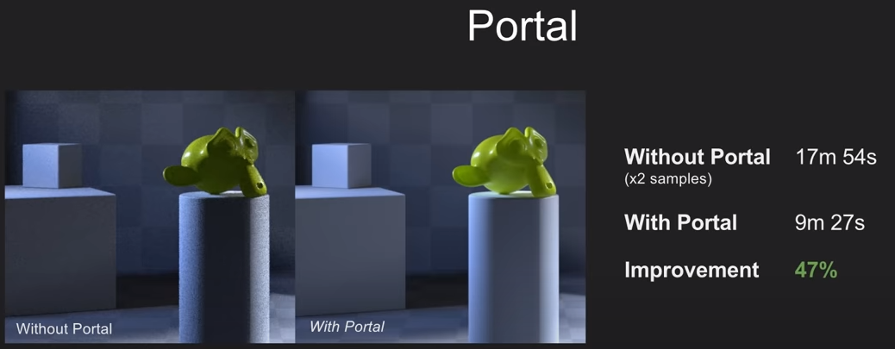

1. **Use GPU**

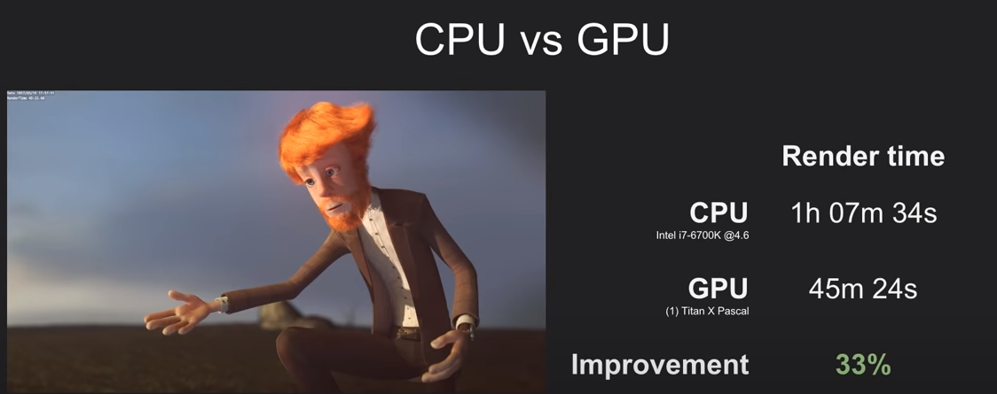

1. **Change the Tile Size**

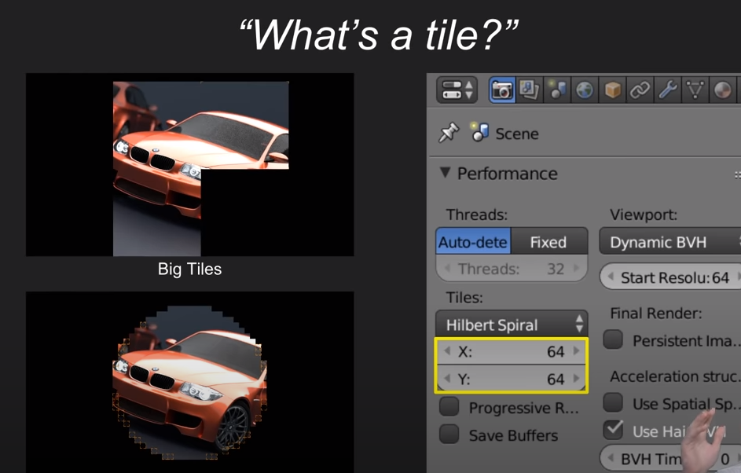

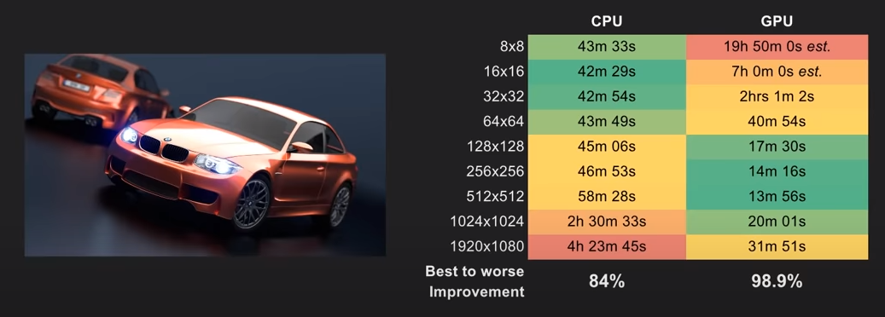

1. **Reduce Samples**
2. **Denoising**
3. **Use the Latest Blender Version**
4. **Use a different OS**
5. **Clamp it (Last result)**

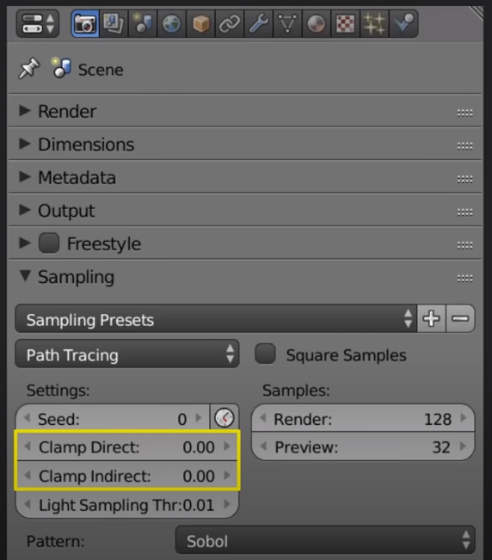

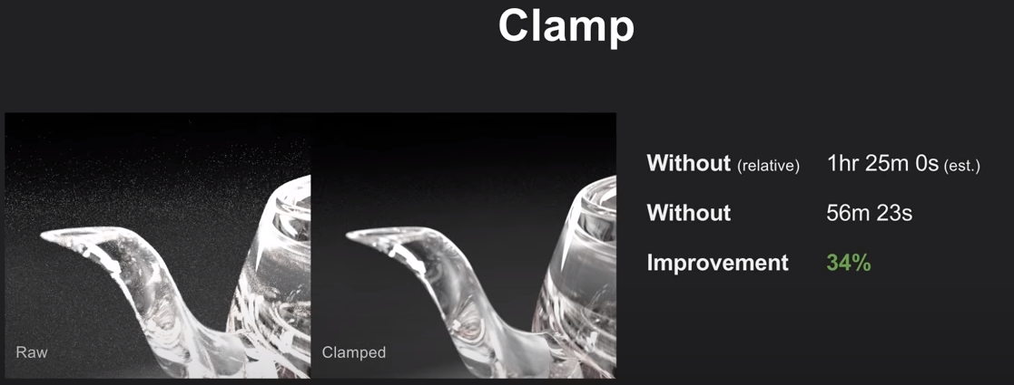

1. **Turn off Caustics**

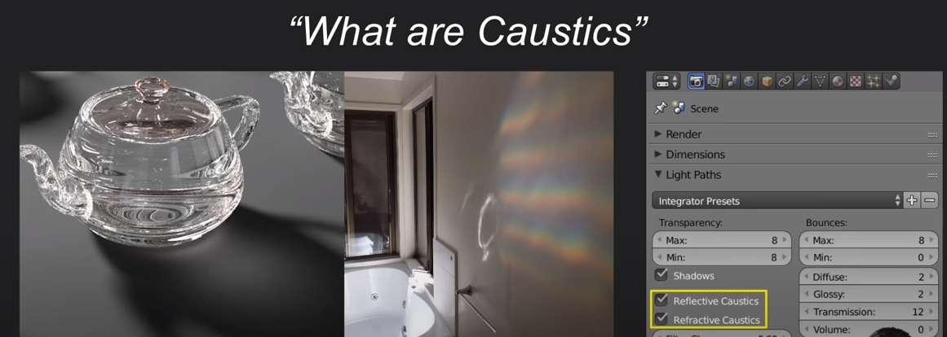

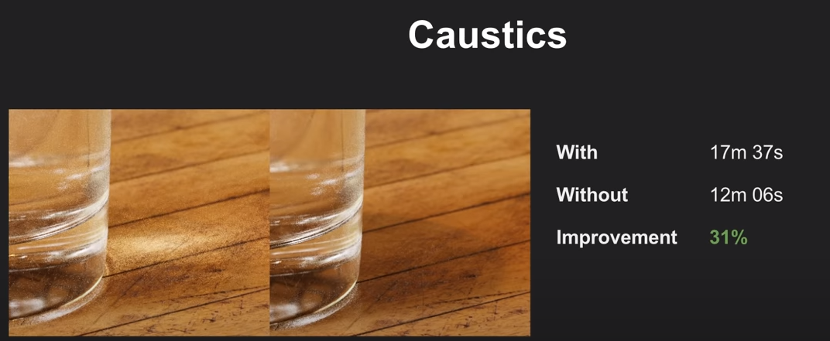

1. **Object Instancing**

* Select objects the press [Ctrl + L] ->Object Data
* [Alt + D]

1. **Adaptive Subdivision**

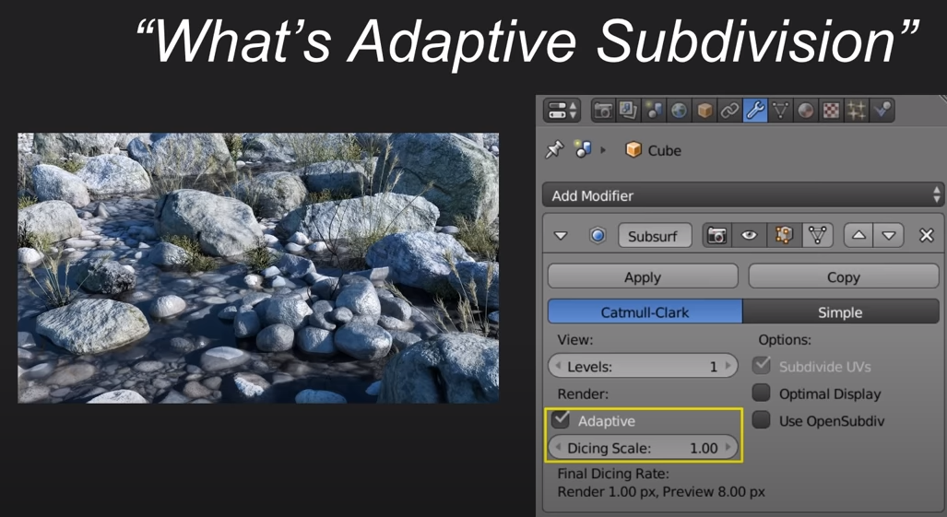

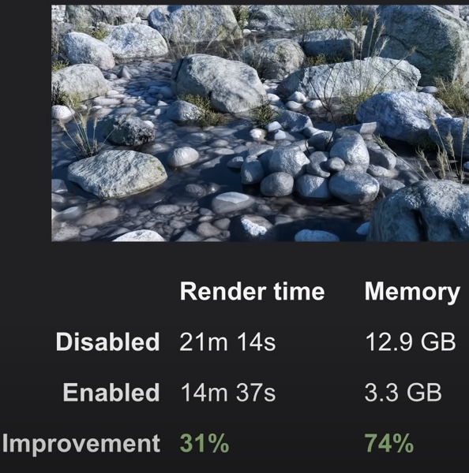

1. **Remove Alpha Transparency**

1. **Reduce the Strand Count**
2. **Remove Volumetrics**
3. **Cut SSS (SubSurface Scattering)**
4. **Enable MIS (Multiple Importance Sampling)**

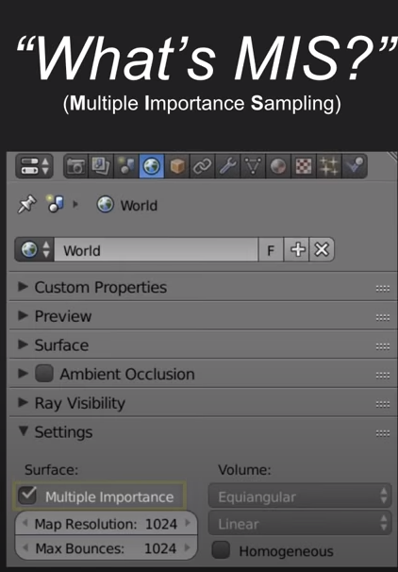

1. **Small Performance Improvements**